**TRAVEL MANAGEMENT SYSTEM USING RPA**

The project “Travel Management System using RPA” is about how to send the mail notification for the frequent customers who are travelling in a particular website. **Robotic process automation** (RPA) is the use of software with artificial intelligence (AI) and machine learning capabilities to handle high-volume, repeatable tasks that previously required humans to perform. Software named as “robot” captures and interprets the customer requirements and initiates operations across multiple digital systems. These software bots which perform these activities can also be termed as virtual or digital workforce in today’s work environment. Results of the project highlight that factors such as security, privacy, reliability and usefulness are significant in advancing RPA in the Travel websites.

**PROBLEM DEFINITION**

The essence of the problem lies in creating a Tour guide system in which user can use the system with augmented reality that can have features of more informative, interactive and user-specific experiences with augmented information. In this proposed system the tourist can recognize or track the contents of an off-line tour booklet and reduce the drawback of interactive visualization and accurate navigation. It requires Fixed point operation and Low memory load of existing system.

**TOOLS USEDUiPath IDE:**UiPath is a software structure to improve automation applications. It runs on Microsoft Windows and it was settled on the top of Net framework and Windows workflow base tools. UiPath scores best in technology category. There are three main components in UiPath.UiPath Studio is a tool that enables you to design automation processes in a visual manner, through diagrams. UiPath Robot executes the processes built in Studio, as a human would. UiPath Orchestrator is a web application that enables you to deploy, schedule, monitor and manage Robots and processes.

**TECHNOLOGY TO BE USED:** UiPath tool

**MODULE SPLIT UP**Module 1: Designing the Web page for Travel management system

Module 2: Mapping filename with the site data

Module 3: Data entry

Module 4: Reporting and sending the mail

**INPUT:**

The input will be obtained from the client through excel with following details:

* Name
* Phone Number
* Gender
* Mail ID
* Transport
* Booking Date
* From and To
* Frequent Traveller

**Input Business File**

* The input file module is used to get the details of the customer which is to be entered in the website.
* The customer will enter the details in the website and it will be stored in an excel sheet.
* Based on the frequent booking locations of the customers , the mail will be sent automatically with the best offers.

Input Website: [www.travelfly.com](https://www.amazon.in/)Snapshot:

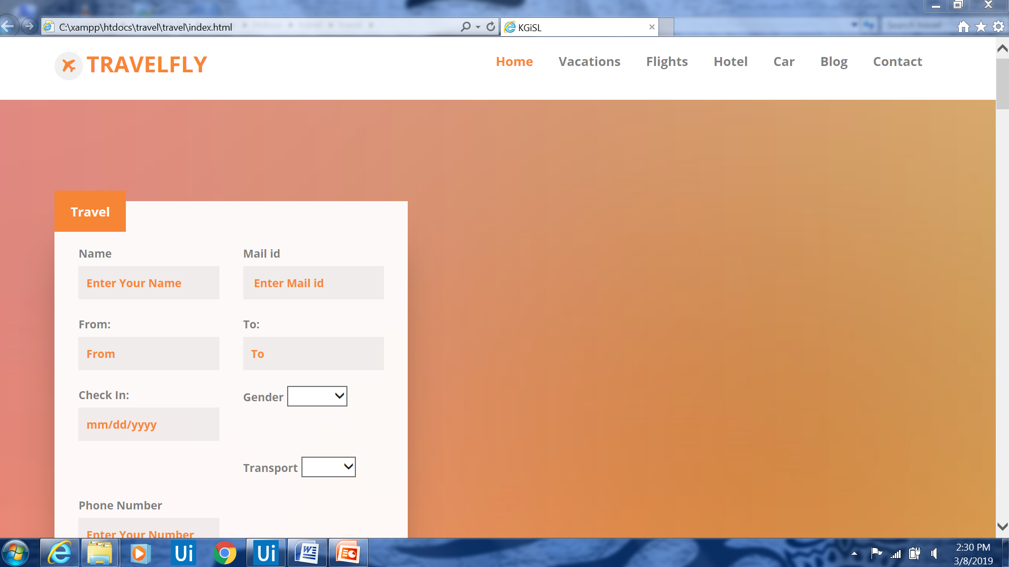

**Web manipulation**

This module is used for manipulation of basic information about the customers. It allows the users to enter the details for their booking. It will save that details in an excel sheet.

**Business file report generation**From the above web manipulation and extraction module, the required details about the customers are manipulated and extracted. These details are then consolidated and collated to form an excel sheet.

**File transfer via mail**

The files are sent via e-mail to the frequent travelling customers.

**OUTPUT:**

The frequently travelled customers are sorted and the output is generated in an excel spreadsheet with these columns:

* Phone Number
* Name
* Mail ID
* Location